Supervisor Preparation
& Guidance

Supervisor Name

This handbook is designed to help you understand the role as a Practice Supervisor and will support you to meet the NMC outcomes for the role.

Before beginning to read each part do time how long it takes you to complete so you can use this resource towards your revalidation.
Understanding the purpose of the Practice Supervisor
Nursing Today
The Nursing and Midwifery Council (NMC) has launched a new framework for the education and training of nurses and midwives, and new standards of proficiency that nurses will be required to meet before they can apply for registration.
Using the links highlighted please access the new standards that have been updated to reflect changes to the way that health care is being delivered. They represent the knowledge, skills and attributes that all future registered nurses must demonstrate to deliver safe, compassionate and effective nursing care. The framework for education and training sets out what nurses and midwives will need to know, and be able to do, by the time they apply for registration.
The new standards for NMC approved programmes are:
· Standards of proficiency for registered nurses
· Standards framework for nursing and midwifery education
· Standards for student supervision and assessment
· Standards for pre-registration nursing programmes
These are available on the Nursing and Midwifery Council website at https://www.nmc.org.uk/standards/standards-for-nurses/
The Standards for prescribers are available at https://www.nmc.org.uk/standards/standards-for-post-registration/standards-for-prescribers/
The Code is embedded throughout the new standards. It would be useful at this point to use the hyperlink and revisit the values and standards identified within the Code (NMC, 2018).
- Prioritise people
- Practise Effectively
- Preserve Safety
- Promote Professionalism & Trust

Understand how the principles of supervision can be used to inform a student’s professional progression

Your role as a Practice Supervisor
The practice supervisor can be any registered health and social care professional working in a practice environment, therefore all nurses and midwives in any practice learning environment should be able to act as a practice supervisor (NMC, 2018). This resource will help you to prepare for your role as a supervisor in practice. Essentially therefore, you might think of your supervisor role in terms of:

The Supervisor in Practice Role

Key principles of effective supervision
Depending on where your practice area and role is, as a practice supervisor you will have different responsibilities that will include:
- Accountability for your part in the students learning.
- Communicating with the Practice Assessor and Academic Assessor
- Upholding public protection
- Providing inclusive tailored continuous learning experiences that enable students to meet their learning outcomes
- Be a role model
- Giving constructive feedback
- Contributing to decisions on assessment for progression
- Raising concerns about student performance and behaviour

For more detailed information please access the NMC website:
https://www.nmc.org.uk/supporting-information-on-standards-for-student-supervision-and-assessment/practice-supervision/

Supporting Learners through supervision in practice
Customising learning to the individual student, considering them as an individual aligns with the delivery of person-centred care embodied within the Code (NMC, 2018).
Although not an exact science, think about your own learning style and that of your student. Supervision and assessment of a student will be carried out by separate people who have a different focus on the relationship with a student but work together to come to a decision on their progress. Supervisors will coach, mentor and support students as they develop skills knowledge and competence. The Assessor will make a decision on a student’s progress based on the evidence collected by Supervisors For more information on coaching and supporting students in clinical practice visit your learning resource centre or the Practice Education Facilitator.
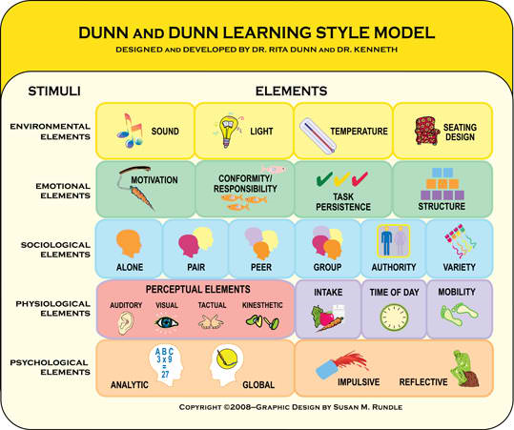
As a practice supervisor draw upon your own knowledge and experience to judge what may be appropriate for each student within your environment. The above diagram raises awareness of the physical barriers to learning.
Learning experiences could include:

- providing and facilitating opportunities for students to practise skills
- sharing knowledge with the student showing them how to put theory into practise
- safely observing students and giving constructive feedback
- empowering students to learn ‘independently’
- delegating learning opportunities to other practice supervisors and anyone else who may suitably enable learning e.g. patients, carers & service users
- empowering students to take responsibility for their own learning e.g. through less ‘hands on’ supervision

Effective Coaching
For effective coaching to take place there needs to be a feeling of trust. Environments where morale is good, management / staff relationships are good, a philosophy of openness pervades and people at all levels feel valued are seen to have the best outcomes for coaching.
Sheppard/ Moscow (2007) state that a positive coaching environment requires the coach to:
- believe in the learner’s potential;
- accept mistakes as long as they are learning;
- be open to feedback;
- regard this as an opportunity to learn yourself;
- acknowledge the importance of feelings as well as facts in the practice experience/workplace;
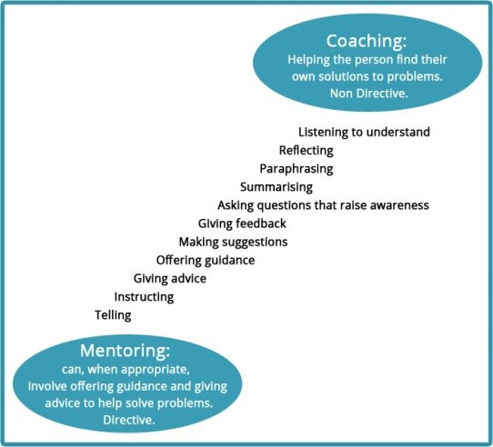
- give support and encouragement.

GROWing your student

The GROW model of coaching can be used to structure conversations between you and your student.
Goal Setting: Agree and understand what goals and/or outcomes the student needs to cover whilst on placement. Goals should be:
SMART, PURE and CLEAR
Specific, Measurable, Agreed, Realistic and Time phased
Positively stated, Understood, Relevant and Ethical

Challenging, Legal, Environmentally sound, Appropriate and Recorded

THE NINE PRINCIPLES OF COACHING
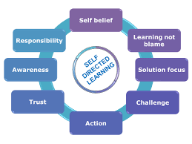
Coaching is positive, non-judgemental, solution focused and challenging:
Although the control of the process lies with the coach, the content always lies with the client, making the coaching experience an empowering, productive and enjoyable one.
The crossover area in the centre of the diagram above represents the times when coaches make suggestions or share their own insights. They usually ask permission before doing this, making a clear boundary between the client’s agenda and their own:
Goal Setting: Agree and understand what goals and/or outcomes the student needs to cover whilst on placement. Goals should be:
SMART, PURE and CLEAR

- Specific, Measurable, Agreed, Realistic and Time phased

- Positively stated, Understood, Relevant and Ethical

- Challenging, Legal, Environmentally sound, Appropriate and Recorded

Supervision supports learning and contributes to assessment
Practice Supervisors provide feedback on the student’s progress towards and achievement of professional proficiencies and skills. This feedback can take different forms including:
- Providing direct feedback to learners on their conduct.
- Providing feedback about proficiencies and skills, whether the skill has been met and providing constructive feedback to improve overall performance
- Collaborating with the student to put action plans in place to improve performance.
- Contribute to the student’s record of achievement by periodically recording relevant observations on the of achievement and may include feedback from patients, carers and service users. have understanding of the proficiencies and programme outcomes they are supporting students to achieve.
- Have understanding of the proficiencies and programme outcomes they are supporting students to achieve.

Practice supervisors should be able to judge what is appropriate for each student, based on their knowledge and experience.

Supervisors must escalate concerns about student performance, feeding back to students and taking immediate preventative action if students’ action may lead to patient harm.
Supervisors must follow, raising of concern, safeguarding and whistleblowing policies which include students and employees.
Student Documentation
An essential part of your role is to fill in relevant parts of the student documentation. Please see link for further information. Further training will be given relevant to your organisation. https://onlinepare.net/ Practice Education Facilitators (PEF) and Academic Assessors will also support you with any concerns with documentation.
Practice supervisors contribute to the assessment process taking into account the student learning, the stage of learning, student competence, and other considerations such as reasonable adjustment.

- Do arrange to meet or liaise with the Practice Assessor, this will depend on where you work.

- Direct communication with practice and academic assessors is necessary to share your views on student achievement or underachievement of proficiencies at each part of the programme

- Identify where work needs to continue and document your views with rationale on student achievement.

- Do access helpful resources on online PARE (Practice Assessment Record and Evaluation) for information on how to have difficult conversations when students are not achieving. https://onlinepare.net/
Pleas contact the PEF and Practice Assessor for support if you need to raise concerns with learner progress.
For further clarification, please ask your local Practice Education Facilitator after reading the NMC online guidance
https://www.nmc.org.uk/supporting-information-on-standards-for-student-supervision-and-assessment/practice-supervision/

5. Personal and Professional development and Revalidation
Activity; Every three years nurses undertake their own revalidation. You can reflect on the Practice Supervisor role and use this resource as part of your revalidation.
http://revalidation.nmc.org.uk/download-resources/forms-and-templates/
