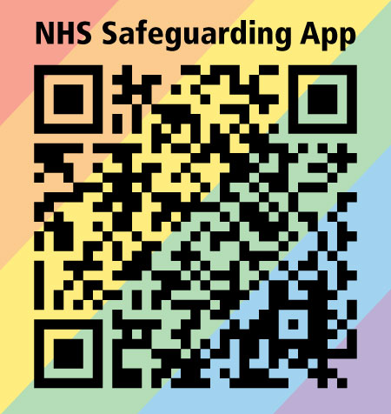 North West region Safeguarding Newsletter -  

**Commissioning of training/learning for regional colleagues – Please Note:**

The NW region Quality & Safeguarding team regularly commission (pay for) training sessions to support the competencies and skills in the system relating to safeguarding and other training needs that are identified. These sessions are at a cost per delegate and free to delegates at a cost to the NHS.  We repeatedly have nonattendance with no explanation or notice, acknowledging, that there are difficulties at the moment due to COVID and staff pressures.

Please consider carefully before registering and if you are unable to attend, due to circumstances out of your control, please contact the team as soon as possible so that they can try and offer your place to another delegate, thank you.

The team can be contacted at: **[england.northsafeguarding@nhs.net](mailto:england.northsafeguarding@nhs.net)**.

**Key Contacts: To contact the North West Region Quality & Safeguarding Team :** **england.northsafeguarding@nhs.net**

**Hosted by NHS England and NHS Improvement North West Region Safeguarding team.**

|  |  |  |  |
| --- | --- | --- | --- |
| **Training** | **Date & Time** | **Delivered by** | **See flyer for futher details and link to register** |
| Domestic Abuse - Lunch & Learn for professionals who want to increase their knowledge of Coercive Control | 23 February 2022 and 25 March 2022  12.00-13.00 via Microsoft Teams | Luke and Ryan Hart |  |
| Cultural Competence in Safeguarding | 23 March 2022  10.00-13.00 via Microsoft Teams | Power the Fight |  |
| Learning from Safeguarding Adult Reviews: Self Neglect | 1 April 2022 and 10 May 2022  09:30 – 16:30 via Microsoft Teams | Professor Michael Preston-Shoot |  |

# Home Office funded Harmful Sexual Behaviour Support Service Launches

The [Harmful Sexual Behaviour Support Service](https://swgfl.org.uk/harmful-sexual-behaviour-helpline/), run by [SWGfL](https://swgfl.org.uk/harmful-sexual-behaviour-helpline/) in partnership with the [Marie Collins Foundation](https://www.mariecollinsfoundation.org.uk/), is now available to safeguarding professionals across England and provides the tools to equip and empower practitioners to address the alarming normalisation of harmful sexual behaviour in children and young people.

The telephone and email support, which is funded by the Home Office and developed in collaboration with the Department for Education, is available **Monday – Friday, 8am to 8pm**.

Call: **0344 255 0623** or Email: [**hsbs@swgfl.org.uk**](mailto:hsbs@swgfl.org.uk).

See attached for further information

1. How will it support you?
2. Why act not?
3. What is Harmful Secual Behavior?



**Patient Safety Update - 25 January 2022**

This update from the NHS National Patient Safety Team pulls together key information that you or your clinical governance/patient safety leads might need to know but could otherwise miss. It is not intended for general circulation within your organisations.



**Child Death Overview Panel (CDOP) for GPs**

To encourage engagement with CDOP for GPs, please see attached, which has been received from the Merseyside CDOP team who asked us to share and are happy for you to “pinch with pride”.



**Safer Recruitment Training**

NHS England and Improvement North West have commissioned nine cohorts of Safer Recruitment training delivered by the NSPCC. Safer recruitment is an essential part of safeguarding. It is important you have rigorous safer recruitment at the heart of your organisation. See attached flyer for futher details.

