

**The North West**

**Health & Wellbeing Newsletter**



Welcome to the February edition of your H&WB Newsletter!

Don’t forget you can access all our health and wellbeing offers, information and more by joining our NHS Future platform using this link:

[**North West Staff Experience and Engagement Community of Practice**](https://future.nhs.uk/NorthWestStaffExperience/grouphome)

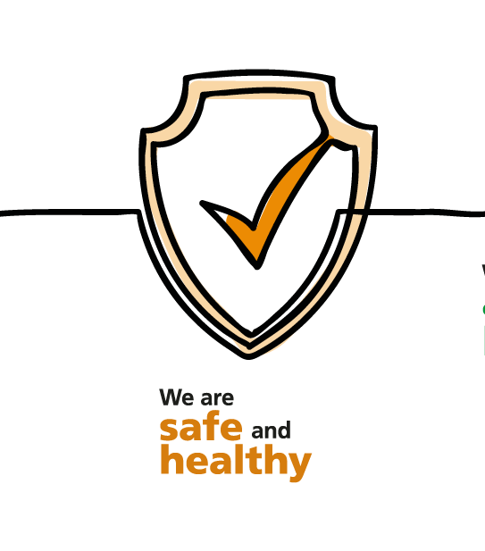

**How are you doing?**

If you’re having a tough day, feeling overwhelmed, or just have a lot on your mind, know that you’re not alone.

**Samaritans**: call the confidential helpline on 0800 069 6222 (07:00-23:00, Mon-Sun) or text FRONTLINE to 85258 (24/7)

**Hospice UK**: for bereavement and trauma support, call 0300 303 4434 (08:00-20:00, Mon-Sun)

or access the **North West hubs** [**here**](https://www.england.nhs.uk/supporting-our-nhs-people/support-now/staff-mental-health-and-wellbeing-hubs/north-west-hubs/) for more support options.

**Vaccination as a condition of deployment for all healthcare workers**

The Department of Health and Social Care (DHSC) announced on 9 November 2021 that individuals undertaking CQC regulated activities in England must be fully vaccinated against COVID-19 no later than 1 April 2022. The regulations will apply equally across the public (NHS) and independent health sector

Thursday 6 January marked the start of the 12-week grace period that allows unvaccinated individuals to have had their first dose by **3 February 2022**, in order to have received their second dose by the **1 April 2022 deadline.**

You can find the guidance that has already been published [**here**](https://www.england.nhs.uk/coronavirus/publication/vaccination-as-a-condition-of-deployment-for-healthcare-workers-phase-1-planning-and-preparation/)**.**

For queries on Vaccination as a condition of Employment guidance contact [**england.vcodguidance@nhs.net**](mailto:england.vcodguidance@nhs.net)

[Frequently asked questions](https://internalcommunications.cmail20.com/t/d-l-akjlitt-jkdrlitde-d/) (FAQs) which accompany the [‘Vaccination as a condition of deployment (VCOD) for healthcare workers: Phase 1 – Planning and preparation’](https://internalcommunications.cmail20.com/t/d-l-akjlitt-jkdrlitde-h/) and [‘Phase 2: VCOD Implementation Guidance‘](https://internalcommunications.cmail20.com/t/d-l-akjlitt-jkdrlitde-k/).

**Supporting our NHS people affected by Long Covid**

‘Long COVID’ is commonly used to describe signs and symptoms that continue or develop after acute COVID‑19. It includes both ongoing symptomatic COVID‑19 and post‑COVID‑19 syndrome (NICE, 2020).

Support is available to NHS colleagues affected by Long COVID **-** [**more information**](https://www.england.nhs.uk/supporting-our-nhs-people/support-now/supporting-long-covid/)

Detailed guidance on how to support colleagues affected by Long COVID is available - [**more information**](https://www.nhsemployers.org/articles/supporting-recovery-after-long-covid)**.**

**Join the next NHSEI Wellbeing Community Event where you will be able to take away information and guidelines on how to support the wellbeing of our NHS people who are affected by Long COVID on 9th February 2022.**

Register using this link [**Supporting our NHS people affected by Long COVID**](https://www.events.england.nhs.uk/events/supporting-our-nhs-people-affected-by-long-covid)





**Looking after YOU**

**Award winning**

A total of **14,677 sessions** have been booked since the service launched in April 2020.

**Ongoing support for our Primary Care Staff.**

There are three confidential coaching offers designed to be easily accessible and tailored to you.

Experienced coaches can help you as an individual, support you to manage your team and reflect on your career goals and ambitions.

Use the links below to find out more information on how to gain the support you need:

[**Looking after you too – you and your wellbeing**](https://www.england.nhs.uk/supporting-our-nhs-people/support-now/looking-after-you-confidential-coaching-and-support-for-the-primary-care-workforce/looking-after-you-too/)

[**Looking after your team – you and your team**](https://www.england.nhs.uk/supporting-our-nhs-people/support-now/looking-after-you-confidential-coaching-and-support-for-the-primary-care-workforce/looking-after-your-team/)

[**Looking after your career – you and your career**](https://www.england.nhs.uk/supporting-our-nhs-people/support-now/looking-after-you-confidential-coaching-and-support-for-the-primary-care-workforce/looking-after-your-career/)

**Support available to you**

Helping you manage your own health and wellbeing while looking after others.

In the current climate of increasing pressures on our healthcare system, our NHS people are facing significant stresses.

We must all encourage each other to seek help – and seek it at the point at which it is needed.

Leaders and teams are encouraged to offer their colleagues support to stay well at work, and to keep offering it consistently to help our staff care for their patients, long term.

**Click Here**

[Supporting-our-nhs-people/support-now](https://www.england.nhs.uk/supporting-our-nhs-people/support-now/)



**Health and Wellbeing**

**Training Dates**

**For Wellbeing Guardians**

**4th Community Conversation Event** is an opportunity for guardians to come together in an action learning style environment.

Please register here [**Community conversations**](https://www.events.england.nhs.uk/events/community-conversations-4)to attend the event on **9 February 2022 from 1.30pm-3pm**

**Wellbeing Champions Monthly Development Session:**

**Understanding the role of the Wellbeing Guardian** and how this fit with your role as Wellbeing Champion

**Register**: [**Understanding-the-role-of-wellbeing-guardians**](https://www.events.england.nhs.uk/events/health-and-wellbeing-champions-understanding-the-role-of-wellbeing-guardians)to attend the event on **17February 2022 from 12pm-1pm**

**For Line Managers**

**Supporting colleagues to have safe and effective wellbeing Conversations,** training is still available to 31 March 22

Use this [link](https://www.england.nhs.uk/supporting-our-nhs-people/support-now/having-safe-and-effective-wellbeing-conversations/) to book your place on a session

**National Events Taking Place Throughout February**

**LGBT+** History Month [**Click Here**](https://lgbtplushistorymonth.co.uk/)

National Heart Month [**Click Here**](https://www.twinkl.co.uk/event/national-heart-month-2022)

Breathing Space Day **1 February** [**Click Here**](https://breathingspace.scot/)

World Cancer Day **4 February** [**Click Here**](https://www.nhsemployers.org/articles/supporting-our-most-vulnerable-people)

Time to Talk day (lets end Mental Health Discrimination **7 February** [**Click Here**](https://www.time-to-change.org.uk/take-action)

Children Mental Health Week **7 – 13 February** [**Click Here**](https://www.childrensmentalhealthweek.org.uk/)



**LGBT+ History Month 1st – 28th February 2022**

LGBT+ History Month is a month-long annual celebration of lesbian, gay, bisexual, trans, and non-binary history, including the history of LGBT+ rights and related civil rights movements.

In the North West we have developed the following schedule of activities for everyone to join

**LGBT+ History Month Launch** 7 February [**Join Meeting**](https://teams.microsoft.com/dl/launcher/launcher.html?url=%2F_%23%2Fl%2Fmeetup-join%2F19%3Ameeting_OTk2MTFlMjYtYWMxOS00Nzk2LTg3NjctYmNiOGQ0OTk0N2Uz%40thread.v2%2F0%3Fcontext%3D%257b%2522Tid%2522%253a%252237c354b2-85b0-47f5-b222-07b48d774ee3%2522%252c%2522Oid%2522%253a%252275fb3e04-a104-45a3-938e-8d37189702c7%2522%257d%26anon%3Dtrue&type=meetup-join&deeplinkId=acedab51-e1e3-4566-816e-33c07430785b&directDl=true&msLaunch=true&enableMobilePage=true&suppressPrompt=true) Time: 12:15-13:00

**Support our LGBT+ leaders** 17 February [**Join Meeting**](https://teams.microsoft.com/dl/launcher/launcher.html?url=%2F_%23%2Fl%2Fmeetup-join%2F19%3Ameeting_ZWMwMDUwZmEtYWRkOS00MGQxLTkxMGQtMmQ4NzM4NTdjYmVj%40thread.v2%2F0%3Fcontext%3D%257b%2522Tid%2522%253a%252237c354b2-85b0-47f5-b222-07b48d774ee3%2522%252c%2522Oid%2522%253a%252275fb3e04-a104-45a3-938e-8d37189702c7%2522%257d%26anon%3Dtrue&type=meetup-join&deeplinkId=ee7a3928-21af-4a19-bbd0-04d778887220&directDl=true&msLaunch=true&enableMobilePage=true&suppressPrompt=true) Time: 13:00-13.30

**LGBT+ people in history** 24 February [**Join Meeting**](https://teams.microsoft.com/dl/launcher/launcher.html?url=%2F_%23%2Fl%2Fmeetup-join%2F19%3Ameeting_Njk1OWQ4YzctNWYyYS00YjYwLTljODYtNmUyNTUxMDcwNjk5%40thread.v2%2F0%3Fcontext%3D%257b%2522Tid%2522%253a%252237c354b2-85b0-47f5-b222-07b48d774ee3%2522%252c%2522Oid%2522%253a%252275fb3e04-a104-45a3-938e-8d37189702c7%2522%257d%26anon%3Dtrue&type=meetup-join&deeplinkId=549947f2-d27e-49d2-858e-717ef76b46bf&directDl=true&msLaunch=true&enableMobilePage=true&suppressPrompt=true) Time: 12:30-13:00

**Time to Talk Day**

Time to Talk Day is the nation’s biggest mental health conversation and it’s nearly here! Taking place on Thursday **3 February 2022**, it’s the day that friends, families, communities, and workplaces come together to talk, listen, and change lives.

Join [**Mind**](https://www.mind.org.uk/donate/?gclid=EAIaIQobChMIn42Kr_f78wIVzeh3Ch2W1AYKEAAYAiAAEgJvz_D_BwE)**,** [**Rethink Mental Illness**](https://www.rethink.org/) and [**Co-op**](https://www.coop.co.uk/communities/charitypartnership) and take part in the day by downloading a free conversation starter pack to help you talk about mental health in your community.

**Start a conversation about mental health**

[**Time To Talk Day - Time To Talk Day**](https://timetotalkday.co.uk/)

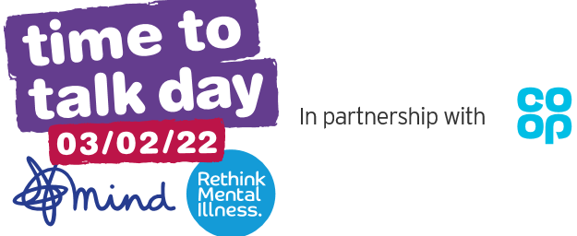

**Developing A 5 Year Strategy to Grow the NHS Occupational Health Identity**

A small number of ‘breakfast club’ style events have been created for all interested stakeholders to attend and learn about the Growing OH drivers and influence how we develop the 5-year strategy around them.

Please find attached below a flyer inviting stakeholders to log into the forthcoming **breakfast clubs.**

* **10/02/2022 - 'Growing our OH people'**
* **24/02/2022 - 'Growing our OH services'**

By attending the sessions, your questions and feedback will help to

co-design a new approach and help craft the future of a new NHS service

and develop our OH people.





**International recruitment toolkit**

Our internationally trained workforce is vital to allow us to respond to Covid and to restore elective services.

Please use this resource to plan your approach to overseas recruitment activity, or to review the quality and efficiency of your existing practices.

This toolkit is for colleagues involved in leading and delivering international recruitment in the NHS. It aims to encourage and enable good practices and processes for the recruitment of international staff across a wide range of professions.

[**International-recruitment-toolkit**](https://www.nhsemployers.org/publications/international-recruitment-toolkit)

**NHS Staff Survey**

Why Will the National Staff Survey Results Not Be Available Until March?

Please find below a helpful infographic which sets out the national timeline for publication of the full NHS Staff Survey across secondary care.



Do you have anything you would like to put in the next update? Or want to share any good practice? If so, please email Stylianos Metaxas on [stylianos.metaxas1@nhs.net](mailto:stylianos.metaxas1@nhs.net). Thankyou.

Don’t forget you can access all our health and wellbeing offers, information and more by joining our NHS Future collaboration platform using the following link:

**[North West Staff Experience and Engagement Community of Practice](https://future.nhs.uk/NorthWestStaffExperience/grouphome)**

Do you have anything you would like to put in the next update? Or want to share any good practice? If so, please email Stylianos Metaxas on [stylianos.metaxas1@nhs.net](mailto:stylianos.metaxas1@nhs.net). Thankyou.

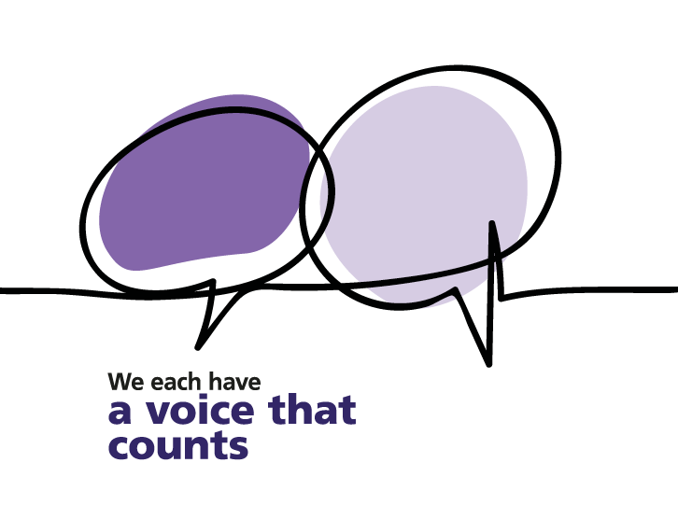



Do you have anything you would like to put in the next update? Or want to share any good practice?

Please email Stylianos Metaxas on: [**stylianos.metaxas1@nhs.net**](mailto:stylianos.metaxas1@nhs.net)