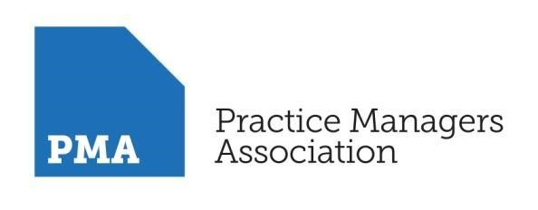
THE BUSINESS OF GENERAL PRACTICE

MODULE: INTRODUCTION TO PRACTICE MANAGEMENT –

THE BUSINESS OF GENERAL PRACTICE, PARTNERSHIPS & FEDERATIONS, WORKING at SCALE, THE ROLE OF TECHNOLOGY, HEALTH & SAFETY, & THE FUTURE OF GENERAL PRACTICE

Web Workshop

7th October 2021

1pm – 5pm

This web workshop will be held on MS Teams, if you are interested in attending this session, please send the following details listed below to jenny@practicemanagersuk.org to register for this session:
- Full name
- Title and date of web workshop you want to book onto
- Email

The PMA introduction to practice management web workshop programme covers all of the key areas that need to be addressed when managing a busy and successful practice. We focus on the issues that regularly arise in medical practice. The module will be delivered as an interactive virtual session with practical guidance to enable participants to map all the techniques and outcomes onto their own practice. Group work is provided on all aspects of the programme so that participants develop their understanding of the topics by interacting with colleagues from other practices.
Training objectives
To provide information and support in order for practice managers, GPs or other members of the practice management team to understand the key areas which need to be addressed when managing a busy and successful practice. These will include:
- Working at Scale
- Partnerships & Federations
- Unlocking the potential of IT in your Practice
- Health and Safety
- The future of primary care

Programme
Welcome & Introduction
Mergers, Partnerships & Federations
- Types of contracts
- Performer's List
- Partnership agreement
- Building agreement
- Revalidation for GPs
- Insurances
- CQC (Care Quality Commission) registration

The future of primary care and support for practice management
- What is clinical commissioning?
- Working at Scale - mergers and federating
- Service provision
- Stakeholder analysis
- Establishment of networks PCNs

Resilience and Wellbeing - Building Resilience
  - What is resilience – how do we achieve it?
  - What are our greatest assets?
  - What motivates people?
  - Managing your resources – people & time
  - Wellbeing – Best practice for your practice
  - Work-life balance – and techniques to achieve it…
  - Stress Management – and coping strategies

BREAK
IT at the centre your practice
- All partners using IT efficiently
- Eireferral system
- Use of IT auditing functions for LES, DES, vaccinations and immunisations
- Quality audits for clinical and prescribing data
- Use of templates
- Read coding - SNOMED
- Standard policy for practice coding
- Telephony
- Labour saving devices
Health and Safety
- Building maintenance and equipment
- Supervising contractors on site
- Recycling all waste and medication
- DEC - Display Energy Certificate
- Calibration of medical equipment
- PAT testing
- Risk assessments
- COSHH
- Infection control/ cleaning schedule
- Trained first aiders
- Disaster recovery plan/business continuity plan
- Fire safety policy
- RIDDOR/Accident book
Discussion forum
Actions & Key Learnings
CLOSE
The Facilitator – Tracy Dell

Tracy is the current NAPC Practice Manager of the Year 2019/20. She has been a Practice Business Manager since 2003 and has over twenty years of healthcare management experience in general practice, primary care, secondary care and the voluntary sector.
Tracy is the lead manager for North Halifax Primary Care Network, is an associate for Calderdale CCG and LMC leading on practice management development and a PM appraiser. She provides independent management consultancy services and training.
Her main areas of interest are: workforce development, collaborative working, optimising the use of IT systems, improving efficiencies and streamlining work processes. Tracy is also a trustee for the Calderdale Carers Project and an advocate for the support and care of our military veterans.

