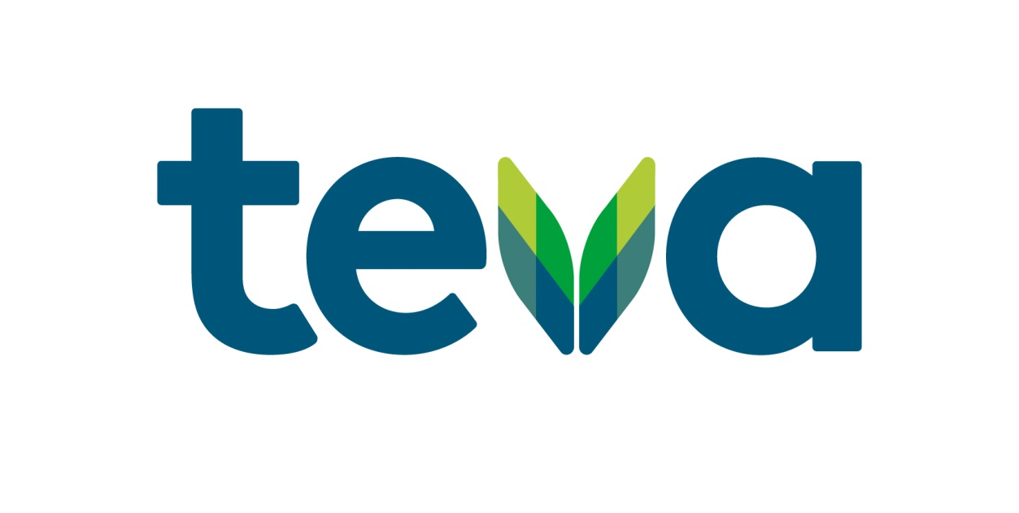
Webinar Invitation
Dr Steve Holmes
COVID19 Recovery

You are cordially invited to attend one of the following webinars;

Thursday 17th June 2021
12:00 pm – 2.00pm

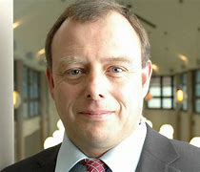
Dr Steve Holmes has worked as a GP for more than 30 years and works as a part-time partner in Shepton Mallet in Somerset. Dr Holmes is education lead for PCRS and is a previous chair. He has been on RCGP council for the last 10 years and has worked extensively with the British Thoracic Society, British Lung Foundation and RCGP with more than 200 publications to his name.
Dr Holmes is passionate that evidence based, patient centred care will improve outcomes and the quality of life of patients.

Post Covid19 Care – What do we need to be ready for?

By the end of this session you should be familiar with normal COVID19 recovery – both those patients managed in the community and those who required hospital admission.

The webinar will also highlight potential problems in recovery and the issues that have arisen from shielding patients and their health.

The session will cover the physical, psychological and social implications of COVID19.

Join us to learn more about the current pandemic and how we can predict and overcome some of the issues we are likely to be facing ahead of the busy winter season.

There will be time for a question and answer session at the end.

NPS-GB-00144
Date of Preparation: April 2021

Teva UK Limited, Ridings Point, Whistler Drive, Castleford, WF10 5HX.

The agenda for the educational webinar will be as follows:

Dr Steve Holmes
(Selected and funded by Teva UK Limited)

“Post COVID19 Care

A 90 minute presentation to discuss the challenging times we are facing over the winter with post Covid19 recovery and caring for these patients.

A Question and Answer Session will also be held at the end.
Welcome and Introductions
10 minutes

Jayne Watkinson
Senior Territory Business Manager
Teva UK Limited

Presentation on Let’s Talk Respiratory

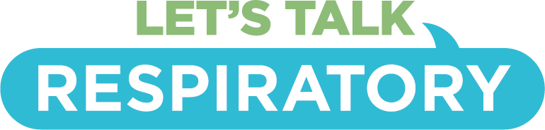

Let’s Talk Respiratory is Teva’s educational programme of supportive materials, resources and some of the latest news in respiratory for both you and your patients. Our aim is to support and encourage you, help empower your patients and to make a real difference to the lives of those living with asthma and COPD.
Sign up for free now at: https://letstalkrespiratory.com/

This meeting is arranged by Teva UK Limited.
Teva UK Limited are funding Dr Steve Holmes honoraria & will be presenting for 10 minutes at the start of the Webinar

To book your place, please contact Jayne Watkinson on the details below;

Email address: Jayne.watkinson@tevauk.com
Mobile Number: 07867 141192

NB: The webinar link will be sent to all registered attendees.

CPD Attendance Certificates will be posted after the event

NPS-GB-00144
Date of Preparation: April 2021

Teva UK Limited, Ridings Point, Whistler Drive, Castleford, WF10 5HX.

