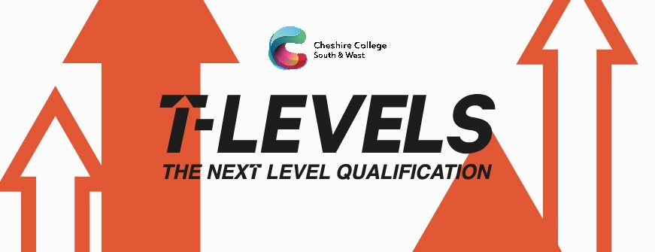
Cheshire College South and West will be rolling out the new T Levels this September and the only college in Cheshire in the second wave of delivery of T Levels.

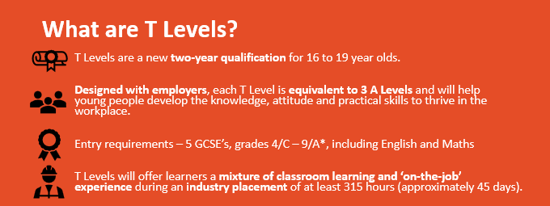

One of the T levels being delivered this September is the Health T Level. Learners studying the Health T Level will be required to complete their 45-day placement over two years starting in Jan 2022 for one day a week then completing in Jun 2023.

We are asking local clinics and surgeries near to our Crewe and Ellesmere Port campuses whether they can offer a T Level placement.

Our learners are required to observe and where appropriate participate in clinical and nonclinical duties to provide high-quality person-centred care. We feel surgeries and clinics provide an ideal environment for learners to gain a wider scope of experience of various clinical procedures, consultations, and medical administration.

A T Level learner will be expected to achieve at a high level for T levels so you will receive a high quality candiadate who can manage their own work load.

We are working with Jamie Ducker from Western Ave Medical Centre here is what he has to say about T levels;

“ We have offered placements to work in the surgery as a Medical Scribe. We can see how a T Level learner can provide value and fresh perspective on the business”

If you feel you would be able to give a learner, the experience of working in your surgery please contact.
Martine Mayo
Work Placement Team Leader Cheshire College South and West
martine.mayo@ccsw.ac.uk 07758454842

